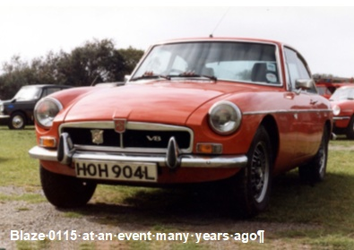**News for a rebuild**

Mike Breedon took the brave step of bidding for a seriously neglected MGBGTV8 at an ACA auction early in 2017 and has been stripping it down. Serious corrosion is everywhere but Mike has decided to cut out and replace all the rusted panels rather than go for a reshell as he wants to maintain the originality, but it is a relentless task.

An uplifting moment came when Graham Hayman

contacted Mike via the V8 Registrar saying “I have come across the restoration article on this V8 that I owned in 1983. I often wondered what had happened to it but was saddened to see the photos. My wife remembers us cleaning the engine with a toothbrush and we won a concours class at an MG Car Club event in Plymouth. It is a pity that I did not know about the auction as I would have bought it myself as it has great sentimental value

for both of us.”

Graham recalls “it had a knob in the centre of the dashboard to adjust the speed of the wipers and I replaced all of the brake lines with cupro nickel and put in the special brake fluid.

It was a preproduction model, one of twelve put out for the press.”

**Future availability of "protection grade" E5**

Recent press reports on the expected introduction of "cleaner E10 petrol" in the UK have made no mention of a lower ethanol alternative, known as the "protection grade", despite its widespread endorsement by the All-Party Historic Vehicle Group (APPHVG) at Westminster. The E10 fuel is so called because it has a 10% bioethanol content. The protection grade fuel is 97-octane E5 with the ethanol content limited to 5%.

**Blaze 0115 at an event many years ago**

Classic car enthusiasts' concerns over higher ethanol

levels in petrol tend to focus on two main areas: technical issues and the future availability and price of lower ethanol petrol as a "protection grade" fuel.

Assurances over the future availability of "protection grade E5" from suppliers of bioethanol fuel seem to leave future scope for wriggle room. But the commercial case for having an E5 97 fuel pump on many forecourts and the price of that fuel will depend on the realities of customer demand and sales revenues for fuel station operators, the logistics of delivering E5 97 to fuel stations and the commercial viability for a fuel station operator of having a pump set aside just for E5 97. For a typical enthusiast doing between say 2,000 to 4,000 miles pa, the effect of a higher price for E5 97 of say 15p a litre could be between £38 and £76 pa.

More on both items at [www.v8register.net/more.htm](http://www.v8register.net/more.htm)