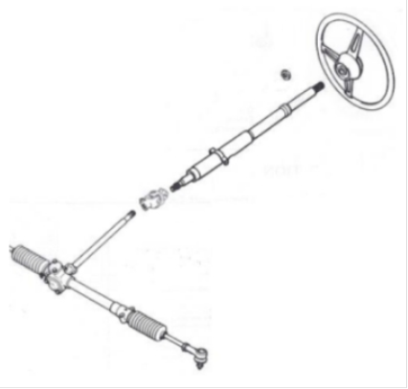 |  |  | Background to this survey  To meet legislation a new Energy Absorbing (EA) steering column was introduced in 1974, concurrent with MGB Rubber Bumper production. This column was fitted to all MGBs, with minimal change, until production ceased in 1980. In the late 1980s or early 1990s Rover Group approached GW King (who had replaced Saginaw as the supplier of steering columns) with a view to their supplying a version of an “MGB steering column” for a new limited production model, subsequently launched as the MG RV8. As the outer column tube was no longer in production this meant using parts that had been stockpiled for replacement MGB steering columns. A compromise was reached that allowed for a supply of columns to be manufactured to fit the new MG RV8 model and leave sufficient stock for spare parts for MGBs and derivatives. The MG RV8 ceased production in 1995 and the position currently is that there are virtually no replacement EA steering columns available for any MGB or derivative.
The main reason for needing a replacement column (after a genuine ‘accident’) is ‘abuse’ in handling a steering column. Typically this is where the column has been subjected to impact loads which shear the breakaway capsules in the top body mounting bracket and/or the shear pins in the inner shaft. This damage is usually caused by either using a ’hammer’ to remove the steering wheel rather than the specified wheel removal tool and/or using force to remove the universal joint from the bottom of the column.

As part of ongoing research into the feasibility of refurbishing MGB collapsible and EA columns (Research Project) it appears that there may be an issue with RV8 upper column bearing failure. The Research Group is looking for your help in establishing if there is a ‘real’ problem and how big a problem it is so that action can be taken to prevent unnecessary failures of or damage to a limited finite resource of these steering columns.

Please respond to this survey (enter text in the light blue areas below) whether you’ve had a problem or not, so the Research Group can get an accurate picture of the current situation. If you know of any other (non MG Car Club) owners with an MG RV8, please get their information on this form so we can build a full picture.

Information required

VIN (last four digits) |  |  | Current mileage | miles
Is the column the unit originally fitted to the car to the best of your knowledge? Yes or No

Part A - Any issues with the steering? Give as much detail as possible, especially column upper bearing

Details – what was the problem?

Date and mileage when the problem occurred

Resolution of the problem, for example any new parts or a replacement column?

Who carried out the “repair”?

Is the steering standard, other than the steering wheel?

If the steering is standard, are you willing for us to contact you for more detailed information? If you are, please provide your contact details here.  If steering is not standard, please go to the “separate survey” below - Part B. |  |  | Name:  Tel:  Email:
When you have completed the survey form above (or Part B below if necessary) please send this document as an email attachment to Nic Houslip (V8 Chairman – V8 Register) at nic@houslip.co.uk

See the personal data undertaking below.

Part B - Separate survey where your car has non-standard steering

VIN (last four digits)

Why was it modified (if known) – for example heavy steering?

What has been modified (if known)?

Details – which parts are non-standard?

Who installed them?

Who manufactured/supplied parts (or did they come from donor vehicle)?

Date and mileage of your car when the steering was modified

Any issues with the modification(s)?

Would you recommend the modification(s)?

If you are willing for a member of the Research Group to contact you for more detailed information? Please supply your contact details

Name

Telephone number

Email

Personal data undertaking of the Research Group members
Any personal data and/or information provided in this survey form and any further data or information you may provide in any subsequent contact or contacts with any member of the “collapsible steering wheel research group” (Research Group) will be used only in connection with the collapsible steering wheel research project (Research Project), will be deleted at any time upon your request made to Nic Houslip, will be held securely and will not be sold or distributed in whole or part to any third party, and within 24 months of the completion of the Research Project all such personal data will be deleted. Any enquiries or matters regarding this personal data undertaking should be sent to Nic Houslip at nic@houslip.co.uk or to 07768 766315.

On completing this survey form, please rename the file by adding your name, save it and then send it as an email attachment to nic@houslip.co.uk For example: 190606-collapsible steering-column-survey-CecilKimber

