Peter Jung  Nancy Crichton (Caledonian Centre Secretary) has been in touch with the "sad news that Peter Jung passed away on Christmas Eve. Peter had been an MG Car Club Caledonian Centre member for many years and had served on the committee for at least the last 10 years. He was a stalwart member of the Centre and will be sadly missed.  The funeral is on Thursday 22nd January 2026, at 2.00pm at Bishopbriggs Crematorium, Glasgow G64 2PZ".  [ Contributor’s name ]  Posted: 260701 | 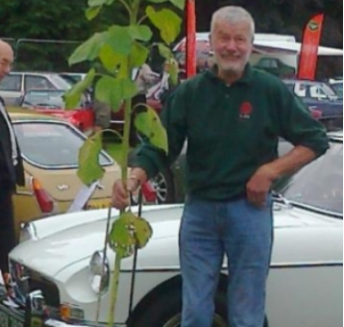 | Peter Jung was a valued V8 Register member who attended many of the V8 tours and the events at Silverstone and was on the V8 Add-On Tour at Dundonnell in 2009.  Tony Smith remembers Peter Jung as a very loyal MG owner and a member of the V8 Register who was a Caledonian Centre committee member for many years".  Ian Lindley says "Peter was a true enthusiast who will be sadly missed. He loved his RV8 certainly enjoyed “power” under his right foot".  Mike Lane was "saddened beyond words when he heard of the news of the passing of our dear friend, Peter Jung. We spent many enjoyable years touring in our RV8s".
Notes
- Always do a search of the V8 website and online to check if there are any items on the topic and then add a link (hyperlink) that they can click and go the webpage or PDF.
- Hyperlinks – just underline the text in your draft and below the drafting provide the link. The V8 Webmaster can then make the hyperlink for you when the NEWS item is uploaded.
- Photos – send them to the V8 Webmaster with a note on how they can be cropped if required. Also check the source/ownership of photos to avoid ownership issues and costs.

